Technical Report on my LAN design for leading healthcare provider, MetroHealth Hospital Headquarters

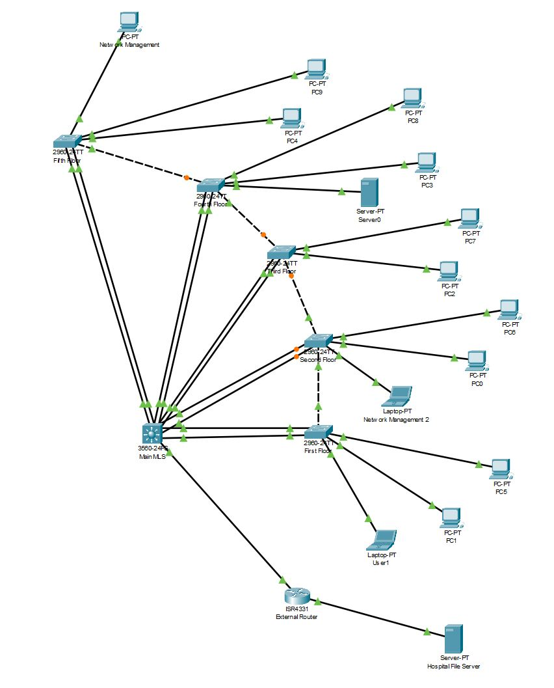

By: Shehab Ahmed (C00295178)
Cybercrime and IT Security Year 2 (SE606)
Submission Date: 21:00, 29th December, 2024
Table of Contents

1. Introduction 2
2. Body 3
2.1. Departmental Segmentation using VLANs 4
2.1.1. Number of VLANs and their purpose 4
2.1.2. VLANs Physically or Logically grouped? 5
2.1.3. Devices per VLAN 6
2.2. Inter-VLAN Communication and External Connectivity 8
2.2.1. Connection Establishment and Stable Communication 8
2.3. IPv4 Addressing with Dynamic Allocation 8
2.3.1. DHCP Server or MLS IOS Integrated? 8
2.3.2. Excluded IP Addresses 9
2.4. Network Redundancy for High Availability 10
2.4.1. Redundancy in Network Design 10
2.4.2. Redundant Devices and Priorities 10
2.5. Network Device Security and Hardening 11
2.5.1. Security Measures 11
2.5.2. Security Scale 13
3. Conclusion 14
4. Appendices 15

- Introduction

The purpose of this report is to explain in detail the design I chose and the reason for the decisions I’ve made in the design. This report will also be going over some flaws in the topology and what I would do in a different setting with different equipment.

There are five major requirements fulfilled in the design and depicted in this report:
- Departmental Segmentation using VLANs
  - How many VLANs?
    - Purpose of each
  - Physically or logically grouped. Or both?
  - Devices per VLAN

- Inter-VLAN Communication and External Connectivity
  - Connection established and Stable communication?

- IPv4 Addressing with Dynamic Allocation
  - DHCP server or MLS IOS integrated? How?
  - Excluded IP Address?

- Network Redundancy for High Availability
  - How redundant is the network?
  - What is important to be redundant?
    - Devices more important than others?

- Network Device Security and Hardening
  - Security measures taken?
    - Flaws?
  - How secure?
    - Mitigation steps?

For each requirement, you’ll be provided with the reason as to why I chose to fulfil the requirements the way I did. These fulfilments will be elaborated on and compared side by side with other competing fulfilments to obtain a deeper understanding of my project. Finally, a conclusion will be provided to summarise why the design I chose best fits the network requirements for MetroHealth HQ.
The Inter-VLAN communication method I chose was the Layer 3 Switch because it has less latency than Router-on-a-Stick and the Legacy approach. Using the Layer 3 switch means that the LAN is scalable beyond 50 VLANs. This will be talked about in more depth below.

- Body

  - Departmental Segmentation using VLANs
    - Number of VLANs and their purpose

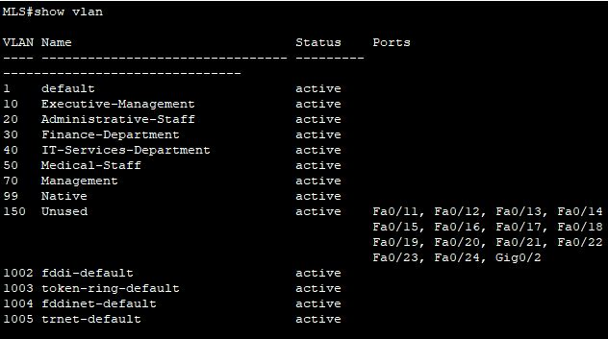
Figure 1 - VLANs set up on the main MLS also on all switches

The minimum requirements for the amount VLANs to use in the design were:
- Executive Management (VLAN 10)
- Administrative Staff (VLAN 20)
- Finance Department (VLAN 30)
- IT Services Department (VLAN 40)
- Medical Staff (VLAN 50)
However, I felt that was too little for a few reasons.
To begin, the five mandatory VLANs to have in the topology are missing a specific group of individuals. The group that will manage this design in MetroHealth. I decided it was best to add a VLAN for Network Infrastructure Management, under VLAN 70 named “Management”. This group will need to manage and control network devices without interference from other traffic. This VLAN will ensure this group of network managers are separated from general hospital executive managers. Keeping traffic from both VLANs separated is crucial to:
- Improve the security of the network – More segmented infrastructure
- Mitigate possible confusions of respected departments in the future
This will also heavily stabilise the network by allowing the management team to access and maintain intermediary devices, even when other user VLANs are experiencing issues (such as high traffic or errors).
Secondly, if there were any guests that needed internet connection for an emergency, they wouldn’t have a suitable VLAN to be placed under, hence bringing risk into the hospital environment. The solution I chose for this was to add a Native VLAN (VLAN 99). This native VLAN would carry user generated and untagged traffic for general data transfer in case a guest is using a legacy device. This ensures they connect successfully to the network. Also this allows us to move ports away from the default VLAN of 1. The users in the Native VLAN are the guests that need internet connection from the hospital. Again, user generated traffic needs to be separated from departments in the hospital for link load balancing and overall network security.
Lastly, the addition of an Unused VLAN (VLAN 150) in the network design serves as a security measure to prevent unauthorized access through inactive or unused ports. By placing all unused or unassigned ports into a dedicated VLAN, any device plugged into these ports will be automatically isolated from the rest of the network, preventing it from gaining access to sensitive hospital resources or inadvertently interfering with network traffic. This configuration helps to:
- Mitigate the risk of unauthorized devices connecting to the network like;
  - Malicious Actors
  - Rogue Devices
- Ensure all devices are intentionally connected and properly secured
The unused VLAN acts as a safeguard to the network, ensuring that only properly configured and authorized devices are active and functional on the network.
In conclusion, the:
- Management VLAN ensures that network management traffic is securely isolated from regular user traffic.
- Native VLAN allows for the seamless handling of untagged traffic, ensuring compatibility with legacy devices and simplifying trunk link operations.
- Unused VLAN adds an extra layer of security by preventing unauthorized devices from accessing the network through unused ports.

    - VLANs Physically or Logically grouped?

In the hospital's network design, VLANs are logically grouped rather than physically grouped to provide greater flexibility, scalability, and efficient management of network resources. Logical grouping allows the hospital to optimize its network traffic, improve security, and better allocate resources across different departments, regardless of their physical location in the building. Below are the key reasons why I chose to logically group the VLANs instead of physically grouping them:
- Network Scalability and Flexibility:
Logical VLAN grouping allows departments to be segmented based on function, rather than physical location. This flexibility enables departments to expand, relocate, or change without needing to rewire the network. For example, if a department grows or moves to another floor, its VLAN membership remains the same, simplifying network management and reducing disruption.
- Simplified Network Management:
Logical VLANs make network management more efficient by allowing administrators to configure policies, permissions, and routing based on logical groupings of users, rather than having to manage network configurations based on physical layout. This leads to reduced complexity in managing access control, applying security policies, and troubleshooting network issues.
- Cost-Effectiveness:
By logically grouping devices into VLANs, the hospital can make more efficient use of existing network infrastructure without needing to invest in additional physical hardware, such as separate switches for each department. This reduces the overall cost of the network while still achieving the necessary segmentation and security.
- Simplified Troubleshooting:
Logical VLANs simplify network troubleshooting by enabling network administrators to isolate issues to specific VLANs, rather than being limited to the physical layout. This helps in quickly diagnosing problems, reducing downtime, and ensuring that critical services, such as patient records or medical equipment monitoring, remain operational.
Enhanced Resource Allocation:
Logical VLAN grouping helps allocate network resources efficiently. For example, devices in the IT Services Department or Medical Staff VLANs can be given higher bandwidth or priority, while departments with less demanding network requirements, like Administrative Staff, can be assigned lower priority. This improves the overall performance of the network, ensuring that critical applications receive the necessary resources.

    - Devices per VLAN

Having more than one device per VLAN is crucial to know if frames and packets can be sent and received from:
Scalability and Future Proofing
Current Limitation: Adding too many devices in a VLAN right from the start can lead to potential scalability challenges later. If the hospital network grows and additional devices are added, it may lead to the need for more complex VLAN re-structuring, network expansion, and reconfiguration.
Why two devices per VLAN: Keeping the number of devices to a manageable level allows for more flexible growth. New devices can be added to VLANs without needing to redesign the entire network. For example, as the hospital adds more medical equipment or staff, new devices can be easily accommodated without overwhelming the existing network infrastructure.
Broadcast Traffic Management
Current Limitation: VLANs help reduce broadcast traffic by isolating network traffic to a specific set of devices. However, each additional device within a VLAN will receive broadcast traffic from every other device on the same VLAN. In a hospital, where there could be large amounts of data flowing between departments (e.g., patient records, medical imaging), this could lead to heavy network congestion.
Why two devices per VLAN: By keeping the device count low, you minimize unnecessary broadcast traffic within each VLAN, improving network performance. For example, too many devices in the Medical Staff (VLAN 50) could cause unnecessary broadcast storms, impacting critical systems like patient monitoring or real-time diagnostics.
Spanning Tree Protocol
Current Limitation: Adding more devices to a VLAN could potentially impact the stability of your network, especially in this design where there are redundant links between the switches. The Spanning Tree Protocol (STP), which is used to prevent network loops, may have to process additional traffic or recalculate paths more frequently as the number of devices in a VLAN grows.
Why two devices: Limiting the number of devices per VLAN helps STP function more efficiently. Fewer devices means fewer paths for STP to manage, reducing the likelihood of physical network loops or unnecessary recalculations, which can impact overall network stability.
Overall, adding more devices to each VLAN might provide some flexibility and space to grow, but in my design, the number of devices were limited to 2 per VLAN. For MetroHealth, this is a much more balanced approach. It ensures prioritized requirements are met, such as security, reliability, scalability for the future and overall network performance.
  - Inter-VLAN Communication and External Connectivity
    - Connection Establishment and Stable Communication

Inter-VLAN communication is vital for the data in the hospital to reach its destination. In this scenario, a device in VLAN 10 might need to send traffic to a device on VLAN 20. If each VLAN is isolated without inter-VLAN communication, users in one VLAN wouldn't be able to access shared resources located in other VLANs. Without inter-VLAN routing, the network would be fragmented, reducing efficiency and causing operational bottlenecks.
Three main points that need to be covered here are:
- Access to Shared Resources on a different VLAN
- External Internet Connectivity
- Efficient Troubleshooting and Security Management
Users on different VLANs may all need to access external resources like the Hospital File Server. Without inter-VLAN communication, these different VLANs would be isolated, preventing them from accessing this essential service and possibly more in the future. A Layer 3 switch, which routes traffic between VLANs, ensures that all devices can communicate with shared services and external networks without restriction.
Finally, When VLANs can communicate with one another, it’s easier to diagnose and troubleshoot issues across the entire network. For example, if there’s a performance issue with a server shared between different VLANs, the network administrator can trace the traffic across different VLANs and pinpoint where the issue lies. Without inter-VLAN routing, isolated networks would complicate diagnostics and network performance monitoring. Tools that monitor and analyse network traffic and performance rely on inter-VLAN communication to give an overall view of the network's health.

  - IPv4 Addressing with Dynamic Allocation
    - DHCP Server or MLS IOS Integrated?

Using the layer 3 switching inter-VLAN routing method, gave me only two option to which should be my DHCP server?
A stand-alone DHCP server or
MLS integrated DHCP
I decided that using the already configured MLS as the DCHP server would take some management load off the staff in the future.
A key reason for using the Layer 3 switch as the DHCP server is its ability to handle DHCP relay more efficiently. With multiple VLANs in my design, the Layer 3 switch can route DHCP requests between the different VLANs, allowing clients in each VLAN to request IP addresses from the same server. This centralized DHCP service ensures that all devices, regardless of their VLAN, can receive an IP address without requiring a separate DHCP server for each VLAN. This method simplifies network management by reducing the number of devices that need to be configured and maintained, while also improving network performance by ensuring DHCP packets are routed quickly between VLANs without unnecessary delays.
Additionally, this approach ensures that DHCP lease management and IP address allocation are handled in one centralized location, improving visibility and control over the network. Keeping unnecessary devices in the network to a minimum is essential for the network infrastructure to handle packets as fast and as efficient as possible. This is to keep unimportant data transfers minimised for higher bandwidth and lower latency.

DHCP Configuration on the Main MLS
Here is an example for VLAN 10:
MLS(config)# ip dhcp excluded-address 192.168.10.254 /// Exclude IP Address
MLS(config)# ip dhcp pool VLAN10 /// Create DHCP address pool for the VLAN
MLS(dhcp-config)# network 192.168.10.0 255.255.255.0 /// Network and subnet mask
MLS(dhcp-config)# default-router 192.168.10.254 ///Set default gateway for clients in VLAN
MLS(dhcp-config)# dns-server 192.168.10.254 /// Configure DNS server IP that clients use

These commands set up a functional IP address pool for a set VLAN. I configured a pool for each VLAN so that any device from any VLAN in the network can acquire an IP address dynamically (if available). This design meets more than requirement of having a DHCP server, but having it whilst keeping the network performance as optimal as possible for MetroHealth HQ.

    - Excluded IP Addresses

Excluded IP Addresses in relation to DHCP server configuration is used to take an IP address or a set of IP addresses out of a LAN pool to not assign these addresses dynamically. In my design, the reason I took out this set of IP addresses in figure 2 is that I wanted the SVIs on the Main MLS to have statically assigned IP addresses. We don’t want a statically assigned IP address to be dynamically assigned elsewhere at the same time. This can cause connection issues within the network, especially in a healthcare environment.

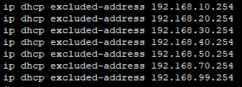
Figure 2 – Excluded IP addresses in the DHCP LAN pool

  - Network Redundancy for High Availability
    - Redundancy in Network Design

A redundant network for MetroHealth HQ is crucial to ensure continuous operation and maintain patient care without disruption. In a healthcare environment, where real-time access to patient data, medical records, and life-saving systems is essential, network downtime can have severe consequences. A failure in the primary network could lead to delays in treatment, miscommunication, and even jeopardize patient safety. By implementing redundancy, such as multiple data paths, the hospital ensures that if one part of the network fails, another can take over seamlessly, minimizing risk and maintaining critical healthcare services. Redundancy also supports compliance with healthcare regulations, ensuring that data remains available, secure, and resilient even during unexpected events or disasters.
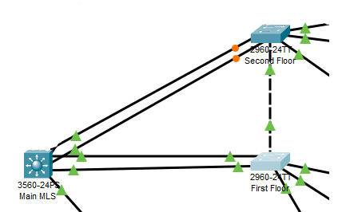
In figure 3, the main MLS is connected to the First Floor switch and the Second Floor switch. Also both layer 2 switches are connected together. In this triangle of connections, if any one link goes down, data will still be able to make its way around this section. That is how I’ve decided to apply redundancy in my design. As an extra, the double links from the MLS to the switches are EtherChannels. This is to make up for bandwidth loss if a link goes down between the two switches (The orange dots on the S2 link are the blocked ports configured by STP to prevent broadcast storms from occurring).
Figure 3 – Redundant links in my design

    - Redundant Devices and Priorities

I have decided that the devices to be prioritized with redundant links in this design are all layer 2 switches and, more importantly, the layer 3 switch. Without the Main MLS and its proper configuration, each VLAN can still communicate within their respected VLANs because the frames don’t need to be routed outside the network. However, attempting to communicate with devices on other VLANs and external devices would be impossible.

You might think connecting every single switch in the topology to every other switch on each floor would be best to maximise redundancy in the network. I thought the same until two key concerns arose:
Complexity and Management Overhead
Complexity of the amount of ports used is challenging
Troubleshooting becomes difficult
Increased chance of human error
Inefficient Use of Redundant Paths
Underutilized and inefficiently used backup paths – STP will block specific paths to prevent loops. If the main path fails, the second path comes into play, the third path very rarely or never, the fourth path may never
Future updates to the network – For any updates to the network in the future, each port has to be updated. This includes the redundant links. Heavily time consuming for an event that may never occur.

  - Network Device Security and Hardening
    - Security Measures

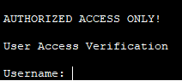
Before setting any usernames or passwords to any lines, you have to let the person know before logging in that there can only be authorized personnel past a certain point. There has to be a warning in case someone thinks it’s open to the public or legal to access.
banner motd AUTHORIZED ACCESS ONLY! In global configuration mode
This sets a banner to let anyone that got to this point that there’s authorized access only.

For the administrator, I decided to keep the username as “administrator” and all passwords as “cisco”. Of course, this is a security vulnerability that should be changed immediately, but for now, it remains as it is for the sole purpose of not forgetting the different passwords to login to devices on the network.
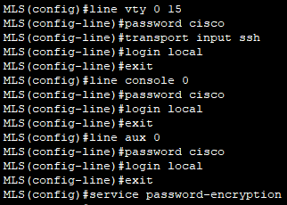
To enhance the security of the network devices in the hospital’s infrastructure, I configured passwords and encryption for various device access lines, including the console (line con 0), auxiliary (line aux 0), and virtual terminal lines (VTY 0-15). This ensures that only authorized users can access the devices, while also securing sensitive login credentials.

Figure 4 - Security commands on MLS
I configured a password for each line, which serves as the first layer of authentication for users attempting to access the router or switch. For remote access, I configured the VTY lines 0-15, which allow users to access the device via SSH only. This was done using the command line vty 0 15 followed by password cisco, ensuring that all virtual terminal sessions are protected by a password. After that, transport input ssh made sure the devices can only be accessed by SSH.
I used the command line con 0, followed by password cisco to set the password for the console line, which is the physical connection to the devices. The same process was repeated for the auxiliary line with the line aux 0 command.
To further increase security, I implemented local authentication for all the lines. By using the command login local, I ensured that the devices would authenticate users based on the locally stored username and password database. This setup ensures that only trusted personnel could log in.
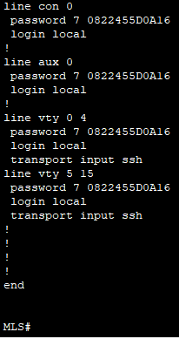
Figure 5 - “show run” after figure 4 commands entered

In addition to setting passwords, I also encrypted the passwords to ensure that they are not displayed in plaintext when configuring or viewing the device. To do this, I used the command service password-encryption, which automatically encrypts the passwords stored in the device’s configuration. This added layer of protection ensures that even if someone gains unauthorized access to the configuration files, the passwords will remain protected and unreadable. This encryption is particularly important for ensuring that sensitive login credentials are safeguarded from potential attackers who might attempt to exploit the device configuration for unauthorized access to the hospital's network infrastructure.

Also the command enable secret cisco in global configuration mode to set an encrypted password for privileged EXEC mode to keep hackers and threats behind as many closed doors as possible. Another layer of security wouldn’t hurt the hospital’s availability in any way.
While encrypted passwords are great security measures for any environment, this is a hospital. This means there has to be extra precautions taken or hackers will find their way in sooner or later through undiscovered vulnerabilities. An extra precaution I decided to take was to add unused ports to the “Unused” VLAN and shut them all down. This was, if a hacker gains physical access to a port, access won’t be granted and the hacker won’t be able to proceed. This is crucial to set another layer of defensive security against potential threats.
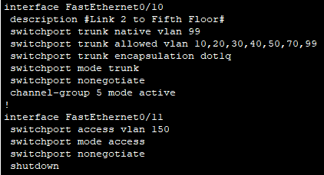
Another point in figure 5 is the “switchport nonegotiate” in f0/10 AND f0/11. This means the switchport mode of these ports won’t change without direct configuration of these ports. If switchport was set to auto, the other end of the link could change it to access or trunk depending on the configuration on that port. I didn’t want this in my design because it poses security threats by giving hackers more freedom in my network.
Figure 6 - f0/10 is an active trunk port on “Native” VLAN.
f0/11 is an inactive access port on “Unused” VLAN
    - Security Scale

It is important to know where the security of a network lands on a scale. To calculate my network basic security vulnerabilities, I used CVSS v3.1 Base Score Calculator on available at: https://chandanbn.github.io/cvss/ (2019). This security calculator runs on a scale from 0 – 10, 0 being impenetrable and 10 being the doors of security vulnerabilities are wide open.

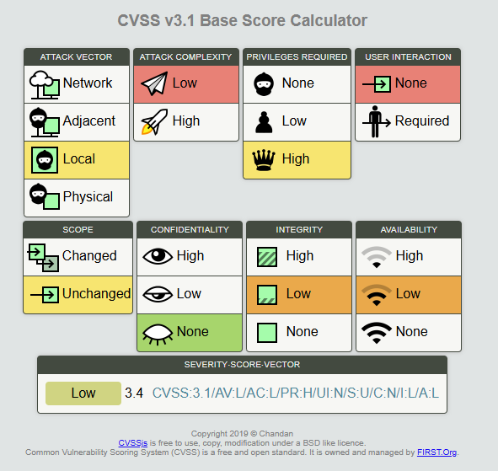
As you can see in figure 6, the network security of my design is rated a 3.4 out of 10 on the CVSS v3.1 Base Score Calculator. This is considered low severity.
This score guarantees that there will be:
- Minimal impact on Operations
- Risk Containment
- Minimal disruption to Patient Care
Not only that, but this proves that major security vulnerabilities have been sealed off and patched. This means the network management team can work on small vulnerabilities that can help bring this rating as close to 0 as possible.
Figure 7. Score given to the network for security

- Conclusion

In conclusion, I believe my design for MetroHeath Hospital is best because it meets all 5 requirements of:
- Departmental Segmentation using VLANs
- Inter-VLAN Communication and External Connectivity
- IPv4 Addressing with Dynamic Allocation
- Network Redundancy for High Availability
- Network Device Security and Hardening
Not only does my design meet all requirements, but it surpasses them with a gap.
The network got segmented into different VLANs depending on departments. On top of the recommended VLANs to add, I added more to ensure traffic around the network is properly separated. Each VLAN has its own description for future configurations in the hospital. This reduces workload for the network management team.
Additionally, it fully supports inter-VLAN routing and external connectivity using the layer 3 switching method. I decided this would be the best inter-VLAN switching method because it divides the workload on all intermediary devices significantly by reducing latency and improving link bandwidth. Not only can devices communicate within each network, but they can communicate with other devices outside the network. This is crucial for a hospital to be able to send and receive data saved on an external server.
IPv4 addressing with Dynamic Allocation has been implemented in my design to reduce the workload of employees having to statically assign every IP address on every end device that is and that will be connected to the network in the future. Not only that, but the gap is that the DHCP server has been implemented on the Main MLS. This reduces the number of unnecessary devices connected in the topology. It also future proofs the network for advancements in technology in years to come.
For Network Redundancy and High Availability, the layer 2 switches have been connected to the floor above and below them. This is in case a link connected to the MLS goes down, traffic can still make its way through the link of another floor to the MLS. This makes the design invulnerable to physical link breaks. Furthermore, the links between the MLS and switches have been upgraded to an EtherChannel. My idea for this was from the workload that these links would be placed under if a link between two switches breaks. This ensures the network performance isn’t affected at events such as this.
Finally, for device security and hardening, every switch (and the external router) have encrypted passwords placed on them in layers. Every line to connect to them is set with a username and a password from the local database. The only way to login to the CLI of the devices is through SSH. The data in this link is encrypted and requires a username and a password. This is an extra precaution set I set to design this topology as secure as possible.

- Appendices

Layer 3 Switch vs Router-on-a-Stick vs Legacy
 | Layer 3 Switch | Router-on-a-Stick | Legacy
Scalability | Most Scalable solution for medium to large organizations | Acceptable solution for small to medium-sized network | Does not scale well. Legacy solution
Performance and Efficiency | Highest performance  Lowest Latency  Highest throughput | Lower performance  Higher latency  Lower throughput (bottleneck due to all traffic going through one router) | Lowest performance  Highest Latency  Lowest throughput
Configuration complexity | Least steps.  Least complex.  SVI configuration for each VLAN | More steps.  More complex.  Subinterface configuration for each VLAN | Most steps.  Most complex.  Time consuming.  Physical interface manually assigned to each VLAN

